Overall Design and style of all pages

We decided to go for a color-palette and overall aesthetic that matches the vibrant colours of a clown/circus.

As our forum’s main target demographic is for clowns, we wanted our website to be playful and inviting but without erring to unprofessional and outdated designs that plague old websites.

This is why we chose to go for a more modern and flat but rounded approach to a lot of elements in our website with regular use of light gradients.

Layout Document

<https://www.figma.com/file/4YNigzwvgZn8lwwLDEaU1W/Clown-Forum?node-id=0%3A1>

Organization of Pages

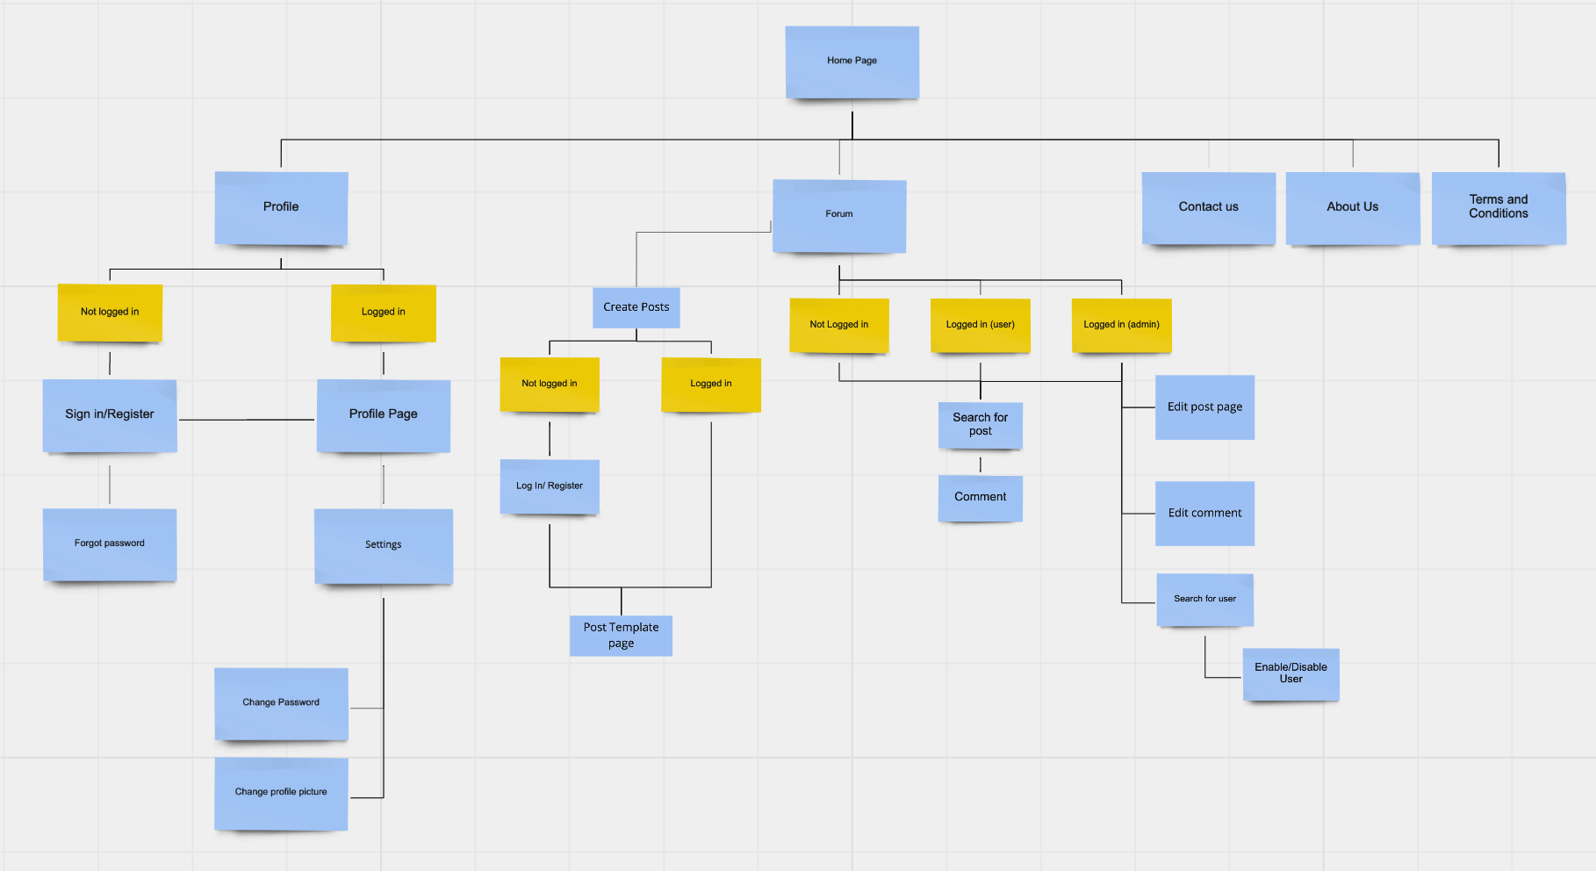

<https://miro.com/app/board/o9J_ljFndQ0=/?invite_link_id=533626346907>

Logic Process

| Search | Have the ability to search for items/posts by keyword |
| --- | --- |
| **Profile** |  |
| Register | Register at the site by providing their name, e-mail and image |
| Sign in | Allow user login by providing user id and password |
| Forgot password | User will be able to recover their password via email |
| Change password | User will be able to change their password by entering their old password and enter a new one two times |
| Change profile picture | … and profile picture by uploading a new one |
| **Forum (user)** |  |
| Create posts | Users will have access to a new page where they have the ability to create a post and publish it. Page will be a form and uses fields to set the specific heading, description and whether to upload a picture. |
| Comment posts | When user clicks on a post, they will have enter a new webpage where they can view all existing comments and also have the option to create their own comments (implemented using a form) |
| **Forum (admin)** | Only works when signed in as admin: |
| Edit posts/comments | We will allow the admin to change post entries and comments from our database. There would be a button to edit posts and comments that would only be visible to admins. |
| Enable/Disable users | We will allow the admin to enable/disable a user’s account from our database. There would be a button(or toggle) to enable/disable their account. |
| **Contact us** |  |
| Submit a request | We would have a self-validating form so that the user can fill out their information and send an email/message to a specified contact email |

Client Side Validation and Security

For elements that need to be validated such as form fields, we want to implement visual cues to show the user that their input is not acceptable by using JQuery and adding classes.

By creating a drop shadow in a bright accent colour and displaying the reason why their input is not accepted, we hope that our interface will be more user friendly.

[insert example? Would need to make something in figma]

Static Design and style of pages

Figma Wireframe Preview:

<https://www.figma.com/proto/4YNigzwvgZn8lwwLDEaU1W/Clown-Forum?node-id=6%3A2&scaling=min-zoom&page-id=0%3A1>